1. a, b, c, and d are consecutive integers such that a < b < c < d

Quantity A Quantity B

The average of a, b, c, and d The average of b and c

1. The average of a, b, c, and d is 5

Quantity A Quantity B

(a + b + c + d)/5 5

1. For the positive integers a, b, and c, the sum of a and b is 75% of c.

Quantity A Quantity B

(3/4)(a + b) (3/4)c

1. A trapezoid has an area of 42 and a height that is less than or equal to 6

Quantity A Quantity B

The height of the trapezoid The length of the longer abase of the trapezoid

1. After one year at her job, Sharon received a 50% increase on her $1,000 weekly salary. Bob, who originally made $1,800 a week, took a 20% percent decrease in salary.

Quantity A Quantity B

Sharon’s new salary Bob’s new salary

1. In an acetic acid purification factory, if the ratio of morning shift of workers to late shift of workers is seven to five, which of the following is impossible to be total number of workers of the factory.
2. 396
3. 408
4. 420
5. 430
6. 432
7. In a group of merchants, 80% of them purchase goods from Asia, and 25% of them purchase goods from Europe. Which of following statement is individually sufficient to calculate what percent of the merchants in the group purchase goods from Europe but not form Asia?

☐ 25% of the merchants who purchase goods from Asia also purchase from Europe.

☐ 15% of all merchants purchase goods from neither Asia nor Europe.

☐ 0% of all merchants purchase good from both Asia and Europe.

1. In a certain university, 50 %of all students take Spanish and 56% of all students take French. If 25% of the students taking French also take Spanish, what percent of all students take neither Spanish nor French?
2. In the range of -3/4 < x < -1/2, what is the least possible value of x?
3. x
4. x + 3
5. x2 – 3x
6. x3 – x
7. x4
8. If n is a positive integer, which of following statement is individually sufficient to provide whether 289 is a factor of n?

☐ The greatest common divisor of n and 344 is 86.

☐ The least common multiple of n and 272 is 4624.

☐ The least common multiple of n and 289 is 289n.

Questions 11-14 refer to following graph

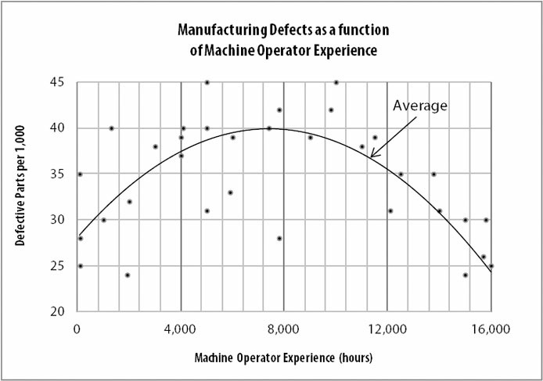

1. On average, the machine operators that produce the fewest defective parts per 1,000 have how many hours of experience?
2. 40
3. 4,000
4. 8,000
5. 12,000
6. 16,000
7. On average, the defective part rate is equal for machine operators with 12,000 hours and with approximately how many hours of experience?
8. 2,000
9. 2,700
10. 4,400
11. 8,400
12. 12,800
13. At approximately what experience level, in hours, do machine operators produce the most defective parts per 1,000, on average?
14. 40
15. 4,000
16. 8,000
17. 12,000
18. 16,000
19. Of the two individual machine operators who had a defective part rate of 4.2%, approximately how many hours of experience did the less experienced operator have?
20. 2,300
21. 5,000
22. 7,700
23. 9,800
24. 15,100
25. In a three-digit positive integer, if the hundreds digit cannot be 1 and the neighbor digits cannot be repetition, how many possibilities of these integers?
26. 729
27. 504
28. 576
29. 448
30. 648
31. Called ultimate addition, u(x) is defined to be the sum of all digit of an integer until the result is single digit integer. If m is a two-digit integer, how many possibility of m such that u(m) = u(50654)?
32. 2
33. 5
34. 8
35. 10
36. 12
37. A student council is to be chosen from a class of 12 students consisting of a president, a vice president, and 3 committee members. How many such councils are possible?
$\frac{12!}{7!5!}$

$\frac{12!}{7!3!}$

$\frac{12!}{3!5!}$

$\frac{12!}{7!}$

38. $12$!
39. An integer is both common multiple of 33 and 65 and common multiple of 14 and 11. What is the units digit of this integer?
40. The following boxplot represents a data set with

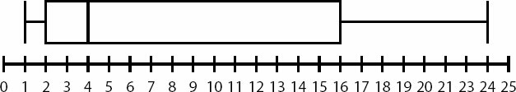

1. a mean of 4 and a range of 14
2. a mean of 4 and a range of 23
3. a median of 4 and a range of 14
4. a median of 4 and a range of 23
5. a median of 4 and a range of 24
6. In a normally distributed set of data, one standard deviation above the mean is 77 and the standard deviation is 10. What is the mean of the data?

c

b

b

b

a

d

abc

8%

a

b

e

b

c

c

e

d

b

0

d

67